Chapter 16, Solution 58.

Using Fig. 16.81, design a problem to help other students to better understand circuit analysis in the s-domain with circuits that have dependent sources.

Although there are many ways to solve this problem, this is an example based on the same kind of problem asked in the third edition.

Problem

In the circuit of Fig. 16.81, let i(0) = 1 A, v_{o}(0) = 2 V, and v_{s} = 4 e^{-2t} u(t) V. Find v_{o}(t) for t > 0.

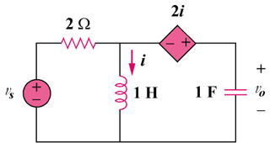

Figure 16.81
For Prob. 16.58.

Solution

We incorporate the initial conditions in the s-domain circuit as shown below.
2
+
−
s
1/s
V_{o}
V₁
2 I
− +
2
4/(s + 2)
1/s
I

At the supernode,
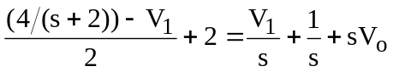
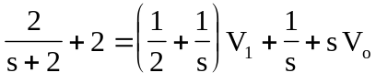 (1)

But 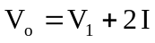 and 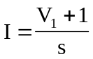
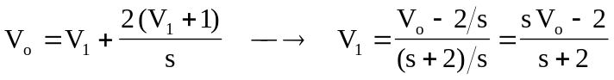 (2)

Substituting (2) into (1)
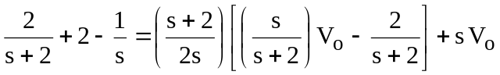
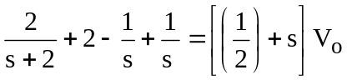
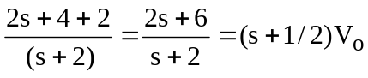
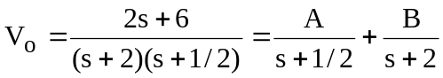

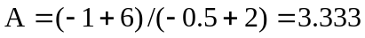,
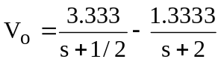

Therefore,
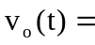 (3.333e^{-t/2} – 1.3333e^{-2t})u(t) V

